PC2
Course: Big Data
Computer Science School
Teacher: Carlos Adrian Alarcon Delgado

Student Code | Full name
U202215375 | Ricardo Rafael Rivas Carrillo
u202216148 | Salvador Diaz Aguirre
U202212243 | Joaquin Fernando Arévalo Alcántara

1. Objective Recap
This deliverable (PC2) extends the data pipeline built in PC1 by moving from raw enriched tables to meaningful per-business feature representations, then measuring how much dimensionality can be discarded without significant information loss. The analytical unit is a single Philadelphia business. The ultimate goal remains hidden-gem detection: identifying businesses with high quality signals but low visibility. A compact, clean feature space is a prerequisite for this scoring.

2. Feature Engineering
The enriched reviews table (~775,955 rows, ~9,930 unique businesses) was aggregated to a single row per business. Four feature blocks were constructed:

2.1 Numeric & Temporal Block
13 features: business_stars, log_review_count, mean_review_stars, std_review_stars, mean_useful, mean_funny, mean_cool, mean_user_avg_stars, mean_user_rev_count, days_since_first, days_since_last, review_span_days, reviews_per_year_recent. All features were standardized with StandardScaler (zero mean, unit variance).

2.2 Categorical Multi-Hot Block
The top 50 most frequent Yelp categories (from the 943-category taxonomy) were one-hot encoded per business using MultiLabelBinarizer. The top 50 covers ≈95 % of all category occurrences. Sample columns: Restaurants, Food, Shopping, Nightlife, Bars, Beauty & Spas, Sandwiches, Home Services, Coffee & Tea, Local Services, ...

2.3 Text TF-IDF Block
All reviews for each business were concatenated into a single document, then vectorized with TfidfVectorizer (English stopwords, bigrams (1,2), max_features=5,000, min_df=5, max_df=0.60, sublinear TF scaling). Output: sparse CSR matrix with ~9,930 rows × 5,000 columns.

2.4 Combined Matrix
A combined matrix was formed by hstacking the standardized dense matrix (converted to sparse CSR) with the L2-normalized TF-IDF matrix. This ensures both blocks contribute on a comparable scale to the downstream SVD.

3. Dimensionality Reduction

3.1 PCA on Dense Matrix
sklearn.decomposition.PCA was applied to the dense numeric+categorical matrix. PCA requires a dense input and works well here because the matrix is small (~9,930 × 63). Up to 100 components were retained.

3.2 Truncated SVD on Text Matrix
sklearn.decomposition.TruncatedSVD (equivalent to LSA — Latent Semantic Analysis) was applied to the sparse TF-IDF matrix. TruncatedSVD is the correct choice for sparse inputs: it avoids centering (which would densify the matrix) and scales to the ~5,000-dimensional text space. Up to 200 components were retained.

3.3 Truncated SVD on Combined Matrix
TruncatedSVD was also applied to the combined matrix, producing a single latent representation that blends structured business attributes with review-language patterns. This is the richest single view for the hidden-gem scoring pipeline.

3.4 t-SNE Visualization
t-SNE was applied to the top 50 components of the combined SVD result (perplexity=30, PCA initialization, random_state=42). Pre-reducing to 50 dimensions before t-SNE is standard practice: it removes noise, speeds up computation, and improves the quality of the 2D layout.

4. Comparison Table
The table below reports cumulative explained variance at k = 10, 20, 50, 100 components, the relative Frobenius reconstruction error at k = 50, and wall-clock runtime for each matrix-method combination.

matrix | method | n_features_in | cum_var_at_10 | cum_var_at_20 | cum_var_at_50 | cum_var_at_100 | recon_error_at_50 | runtime_s
dense (PCA) | PCA | 63 | 0.8433 | 0.9316 | 0.9921 |  | 0.0876 | 0.0
text (SVD) | TruncatedSVD | 5000 | 0.1403 | 0.1856 | 0.2503 | 0.3036 | 0.8001 | 4.3
combined (SVD) | TruncatedSVD | 5063 | 0.79 | 0.885 | 0.9471 | 0.9603 | 0.226 | 4.1

5. Visualizations

5.1 Scree Plot (Cumulative Explained Variance)
The plot below shows how cumulative explained variance grows with the number of retained components for each matrix. Dashed lines mark the 80%, 90%, and 95% thresholds.
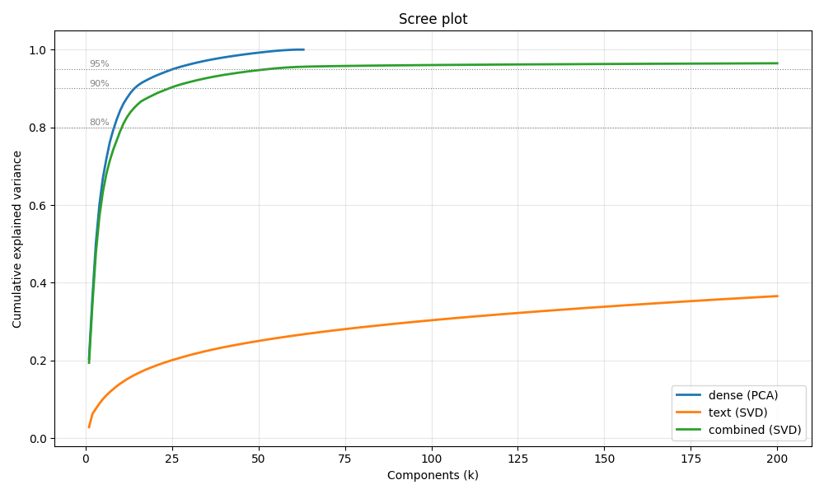

5.2 t-SNE 2D Projection
Each point is a Philadelphia business, colored by its primary Yelp category. Visible clusters confirm that the combined feature representation captures category-level structure without explicit supervision.
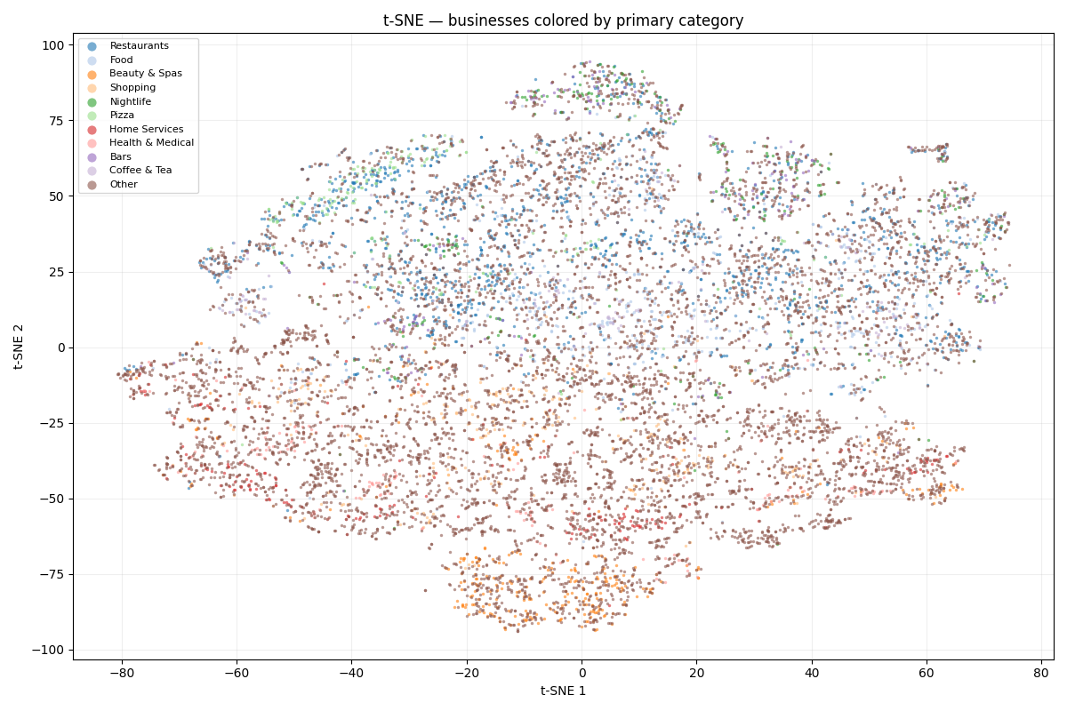

5.3 PCA Loadings Heatmap
Top-20 features by maximum absolute loading across PC1–PC5 of the dense PCA. Red = positive loading, Blue = negative loading.
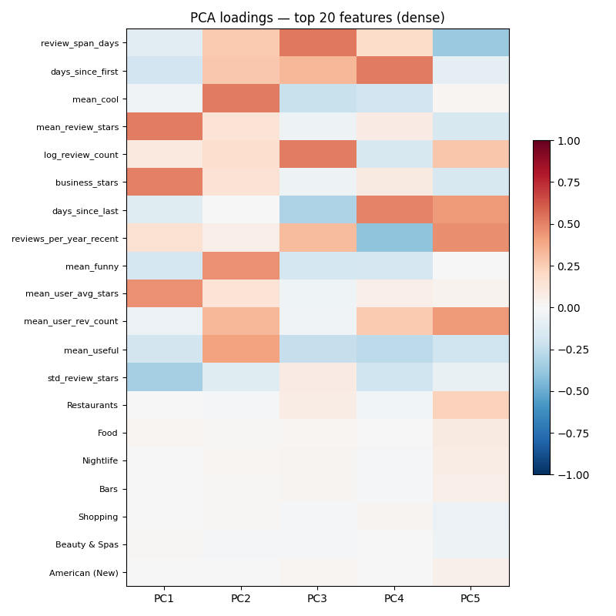

6. Technical Interpretation
The following observations were drawn from the dimensionality-reduction experiment:
dense (PCA) (PCA, 63 input features): 80% in k=10, 90% in k=20, 95% in k=50. Reconstruction error at k=50: 0.0876.
text (SVD) (TruncatedSVD, 5000 input features): 80% not reached, 90% not reached, 95% not reached. Reconstruction error at k=50: 0.8001.
combined (SVD) (TruncatedSVD, 5063 input features): 80% in k=20, 90% in k=50, 95% in k=100. Reconstruction error at k=50: 0.226.
The dense feature matrix (13 numeric/temporal + 50 categorical multi-hot columns) captures aggregate business-level statistics. A relatively small number of components already explains a large fraction of its variance, reflecting redundancy among the numeric aggregates (e.g., mean_review_stars and business_stars are highly correlated).
The text TF-IDF matrix (5,000 bigram features) is much higher-dimensional and sparser. Variance is distributed across many components, indicating a richer but noisier signal. TruncatedSVD (LSA) reveals latent topic structure in the review language that is not visible in the numeric features.
The combined matrix merges both views. Its leading components blend category-frequency and review-quality signals, making it the most informative single representation for downstream tasks such as hidden-gem scoring and business clustering. The t-SNE projection confirms that businesses with the same primary category cluster together in the reduced space, validating the quality of the feature representation.

